Họ và Tên:……………………………...  Lớp:…………………………………….  Trường: TH NGUYỄN KHUYẾN  Ngày kiểm tra:…………………………. | Số  Báo  Danh | KTĐK CUỐI KỲ II NH 2016 – 2017  CHƯƠNG TRÌNH TATC – KHỐI 3
 | Số  Báo  Danh | Giám thị | Số mật mã | Số thứ tự
……………………………………………………………………………………………………………………

ĐIỂM VÀ NHẬN XÉT CỦA GK |  | Giám khảo | Số mật mã | Số thứ tự
Nghe | Đọc Viết Nói: | Giám khảo | Số mật mã | Số thứ tự

READING
Part A: Look and read. Choose the correct words and write them on the lines: (2.5pts)
  stars |   rain |   rainbow |   pen
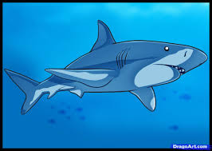  shark | 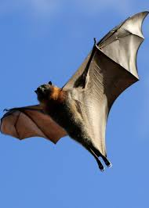 | a bat | 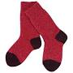  socks
Ex: You can see them in the sky at night. _________stars____
- It lives in the sea. It eats other fish. __________________
- This animal only eats at night. It can fly. __________________
- This is water that falls from gray clouds. __________________
- You wear them on your feet. __________________
- It is colorful. You can see it after the rain. __________________

Part B: Look and read. Write Yes or No: (3pts)


- There are four people sitting around the table.  - The man with a cup is wearing glasses.  - There are more men than women.  - One of the women is wearing a hat..  - There are three cups on the table.  - There is an animal in the picture.  - Everyone is happy. | ____Yes______  __________  __________  __________  __________  __________  __________
PART C: Read the text and choose the best answer.(2.5pts)
Example:
Pat: | Hello Nick! Are you enjoying your weekend? | 3. Pat: | What did you do yesterday?
Nick: | A Yes, thank you.  B Yes, I’ve got one.  C Yes, he does. | Nick: | A We’re going for a drive.  B We went fishing.  C We didn’t stop there.
1. Pat: | What’s the weather like there? | 4. Pat: | Where are you now?
Nick: | A I liked it a lot.  B It’s very hot today.  C No, I’m awake. | Nick: | A I crossed it.  B After lunch.  C Next to a river.
2. Pat: | Who are you with? | 5. Pat: | That’s nice! Well, sorry, Nick. I have to go now.
Nick: | A My son and daughter.  B The café.  C A picnic. | Nick: | A Ok, goodbye!  B Well done!  C Excuse me!

PART D: Read and complete the life cycle of a frog: (2pts)

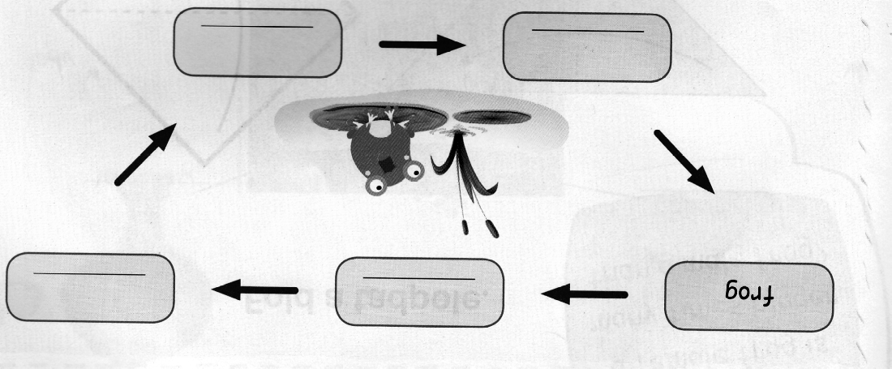

tadpoles frog eggs tadpole with legs froglet

– GOOD LUCK –

